## “WIRELESS ELECTRONICS NOTICE BOARD BY GMS”

## 1Anjali Sampat kalaskar,2 Deepali Dyaneshwar Bhagwat, 3Jawade Appa Kisan

## 4Mahesh Rajkumar Borude 5H.K.Bhangale

1UG Scholar, Electrical Dept. Adsul Technical Campus, Chas, Ahilyanagar

2UG Scholar, Electrical Dept. Adsul Technical Campus, Chas, Ahilyanagar.

3UG Scholar, Electrical Dept. Adsul Technical Campus, Chas, Ahilyanagar.

4UG Scholar, Electrical Dept. Adsul Technical Campus, Chas, Ahilyanagar.

5Asst. Prof. Electrical Dept. Adsul Technical Campus, Chas, Ahilyanagar.

**ABSTRACT:** The most popular wireless digital communication technology is GSM (Global System for Mobile Communications), an open, digital cellular technology that was first implemented in Finland in December 1991. With more than 90% of the market and operations in more than 219 nations and territories, it has emerged as the industry standard for mobile communications as of 2017.. Digital advertisements have become popular nowadays as shopping malls, super markets, airports use digital display boards. From every small institution to big organisation, messages are displayed on digital boards. Cell phone use has increased dramatically during the past 20 years. These days, mobile phones and their associated technology are among the most significant items.

1. **INTRODUCTION**

The intriguing concept of delivering and receiving messages as well as showing the mon digital board was brought about by this extreme use of mobile phones. Through the international roaming feature, the SMS (Short Message Service) capability in mobile phones allows us to send and receive messages anywhere in the globe.. The main aim of this project is to replace the conventional notice boards by wireless digital displays driven by GSM technology. The authenticated user on the sending end sends SMS (notice to be displayed on the board) using his mobile handset to the SIM card loaded in the GSM module (attached to the wireless notice board), which receives the message and passes it to the microcontroller in the arduino nano for storage and then displays the received SMS on the wireless digital board. Only messages with an initial character of * and a final character of "#" are sent to the SIM card at the receiving end of the GSM module. As long as there is mobile network connectivity, the gadget can be utilized anywhere, regardless of where it is deployed. Digital advertising is the way of the future. Nowadays, digital isplays are used in shopping malls and large stores.. Also, in trains and buses the information like platform number, ticket information is displayed in digital boards. People are now adapted to the idea of the world at its fingertips.

Over the years, mobile phone use has skyrocketed. Communication and control have grown in importance everywhere in the world. From elementary schools to huge organizations, notice boards are one of the most popular ways to spread messages. Mobile phones and associated technologies are getting more and more common in today's globe.. Various technical arenas in the field of Telecommunication and Embedded Systems are becoming omnipresent in the people. The use of cell phones has rapidly increased over the last decade and a half. Upgradation in networking technologies has encouraged the development and growth of very dense networks. Now-a-days the general mass prefer communicating while on the move therefore landlines usage has been drastically reduced.

1. **OBJECTIVE**

Designing an automatic, self-enabled, and extremely dependable electronic notice board is the primary goal. A display that is connected to a server system should constantly monitor incoming calls from clients or users, process them, and display the information on an LCD or LED screen. The message displayed should be updated each time a user sends new data, and only authenticated users should be able to access the server.

#### PROBLEM STATEMENT

One essential component of every organization or public utility location, such as a hospital, airport, bus or train station, retail center, or park, is a notice board. Writing out the various notices by hand every now and then is a laborious and time-consuming procedure. A wireless digital display board has been suggested as a solution to the issue. By utilizing SMS (Short Message Service) technology, GSM technology seeks to simplify message transmission..

1. **LITERATURE SURVEY**

**Neeraj Khera , Divya Shukla, Shambhavi Awasthi (2019)** The development of simple and low cost Android based wireless notice board is presented. The proposed system uses eitherBluetooth or Wi-Fi based wireless serial data communication. For this purpose Android based application programs for Bluetooth and Wi-Fi communication between Android based personal digital assistant devices and remote wireless display board are used. At receiver end, a low cost microcontroller board (Arduino Uno) is programmed to receive and display messages in any of the above communication mode. Using the developed system, two different applications for displaying messages on a remote digital notice board and wireless person calling has been implemented. The developed system will therefore aims in wirelessly sharing the information with intended users and alsohelps in saving the time and the cost for paper and printing hardware.

**Mr.P. Blalakrishna, T. Harini, E. Kanaka Jyothi (2021)** Notice board is the primary thing any institution, any Organization and public places like Bus stations, Railway stations and Parks. But day-to-day work of sticking various notices is a hectic process which demands a separate person to

take care of this display. So, to avoid this burden, this paper is proposed with an advanced hi-tch wireless notice board. It is built around a microcontroller (AT mega 2560) which provides all the functionality of the display and wireless control. The notice board has built with GSM technology and has extra features by the usage of mobile application. By using mobile application, we can prevent accessing of any unauthenticated users, falls subscribers and provides high Security. The notice sends through SMS by incorporating GSM module facilitate the communication of displaying message on the notice board via user’s mobile phone. In the present scenario, by using GSM technology, Certain users are fixed to send the message and there is difficult in adding new users but we Have used mobile app which helps in inserting and deleting user’s identity according to the circumstances. This smart notice board is useful in real time applications and information canbe given through our finger tips. It saves more time and reduces the cost of printing. It has advantages of low power consumption and low cost

**III.** **SYSTEM ANALYSIS**

1. **EXISTING SYSTEM**

The current process is shown in the points below. For this project, we text messages to be shown on the LCD screen using a mobile phone. The user uses his mobile device to transmit the message to the subscriber identity module (SIM) number that is installed into the GSM whenever he wants to display it.. The GSM module receives the message. AT(Attention) commands are serially transfer to the GSM from Arduino and then in return the GSM modem transmit the store message through COM port. The Arduino validates the message and then display the message in the LCD display board. Various time division multiplexing techniques have been suggested to make the display boards function efficiently.

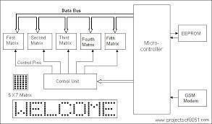The messages (notices) are shown on either a white or black board under the current system. Sometimes, poor writing and management can cause it to be erased. Boards must be maintained on a regular basis to prevent damage. The writing on the board is a little challenging, and it could hurt to write more. Additionally, it could not be visually appealing to people.

#### 

#### PRAPOSED SYSTEM

The Arduino controls the entire process in this proposed project, while the GSM module (SIM 900A) receives the message provided by the verified mobile device and the LCD (16*2) shows the received The block diagram of a wireless notice board that uses GSM technology is displayed in the SMS below..The wireless GSM technology used in the proposed project to display messages on the notice board is efficient, reliable, and faster with minimal errors. It is cost effective system, requires very little maintenance, and is easy to handle and use. It takes the place of outdated and traditional notice boards, which need paper to express their messages. Wireless digital display boards have taken the place of this tiresome and time-consuming task. The digital notice board is becoming more and more popular among both large and small enterprises.

* + - Firstly interface GSM module and arduino Mega 2560 by connecting receiver, transmitter, ground pins of GSM module to transmitter, receiver and ground pins of arduino mega2560respectively.
    - Provide power supply to all the components. With the help of arduinoIDE, execute the program Load the program into arduino mega 2560 controller using USB cable.Insert the SIM into SIM slot in GSM module.
    - Send an SMS to the GSM module using mobile app. Now you can observe the same message on the output display board.
    - Sending messages from any of the remote area to the distant located Electronic-notice board using GSM.
    - For sending the text message from remote area we need to interface the mobile phone with GSM.
    - For developing some of GSM based applications we need to have some commons peripherals including GSM MODEM., SIM, Arduino board, LED, power supply and connecting wires.

#### 

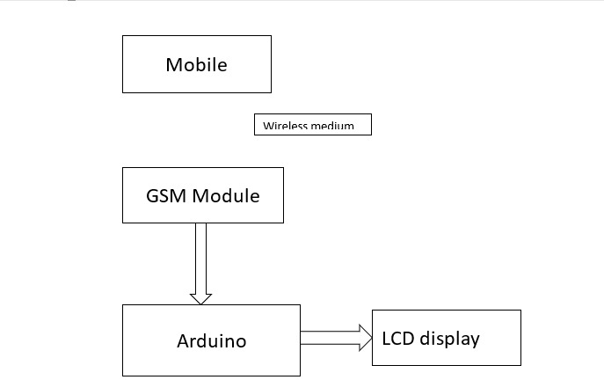

#### IV. REQUIREMENT SPECIFICATION

**4.1 FEATURES** User-friendly: Messages are shown wirelessly on the display unit after being entered on a computer or mobile device.Does away with the need for printers: Printers are useless in this system since we don't utilize papers to present information. Quicker methods of information transfer: Information is transmitted without any delays. After entering, messages are shown in a few seconds.Long Range: As long as we have the required network A GSM modem is a specific type of modem which accepts a SIM card. Itoperates over a subscription to a mobile operator, just like a mobile phone. From the mobile operator perspective, a GSM modem looks just like a mobile phone. A Applications like Now SMS may send and receive messages using the GSM modem interface thanks to the interface that the modem exposes. When setting up your GSM modem or when you connect your GSM mobile phone to the computer, be sure about installing the appropriate Windows modem driver from the device manufacturer. As long as your computer hardware has the available communications port resources, the Now SMS & MMS gateway may support several modems at once. Coverage: Messages can be sent from anywhere in the world.

#### 4.2 HARDWARE COMPONENTS

* + - GSM module
    - Arduino UNO
    - LED

#### 4.3 SOFTWARE COMPONENTS

* + - EMBEDDED C
    - ARDUINO IDE

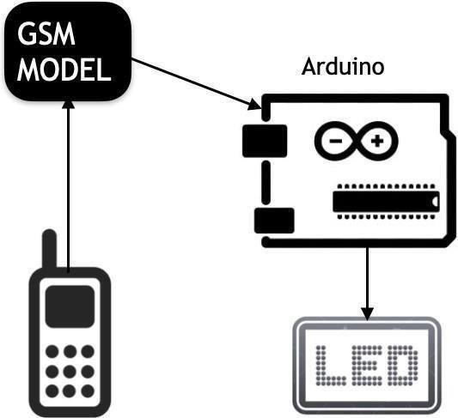

**VII. DESCRIPTION OF PROPOSED SYSTEM**

**4.4 GSM Module**

One particular kind of modem that takes a SIM card is a GSM modem. Like a mobile phone, it runs on a subscription to a mobile operator. From the standpoint of the mobile operator, a GSM modem looks just like a mobile phone. A GSM modem exposes an interface that allows applications such as Now SMS for sending and receiving messages over the modem interfaceMake sure you install the correct Windows modem driver from the device maker when you install your GSM modem or connect your GSM cell phone to the PC.. As long as your computer hardware has the available communications port resources, the Now SMS & MMS gateway may support several modems at once..

Global System for Mobile Communication (GSM) is an acronym for a mobile communication modem. In 1970, Bell Laboratories invented the concept for GSM. It is one of the most used mobile communication systems worldwide.. GSM is an open and digital cellular technology used for transmitting mobile voice and data services operates at the 850MHz, 900MHz, 1800MHz and 1900MHz frequency bands.

The GSM system was created as a digital system for communication purposes utilizing the time division multiple access (TDMA) technique. After digitizing and reducing the data, a GSM transmits it via a channel that has two distinct streams of client data, like asach in its own particular time slot. The digital system has an ability to carry 64 kbps to 120 Mbps of data rates.

**4.5 GSM ARCHITECTURE**A GSM network consists of the following components:

**Base Station Subsystem:** It serves as a conduit between the network subsystem and the mobile station.

It is made up of the Base Transceiver Station, which manages the protocols for mobile

communicatio and houses the radio transceivers.

* + - * It also consists of the Base Station Controller which controls the Base Transceiver station and acts as a interface between the mobile station and mobile switching centre.

**Network Subsystem:** It gives the mobile stations access to the fundamental network link.

The Mobile Service Switching Center, which gives access to various networks like ISDN, PSTN, etc.,

#### 

**5.ARDUINO ARCHITECTURE**

The Harvard design, which has separate memory for both code and data, is essentially used by the Arduino processor. Program memory and data memory are its two main components.While the data is kept in the data memory, the code is kept in the flash program memory.. The Atmega328 has 32 KB of flash memory for storing code (of which 0.5 KB is used for the bootloader), 2 KB of SRAM and 1 KB of EEPROM and operates with a clock speed of 16MHz. The main benefit of Arduino is that programs can be loaded straight into the device without the need for a hardware programmer. The 0.5KB of bootloader that enables the program to be burned into the circuit is the reason for this. All we need to do is write the code and download the Arduino software..

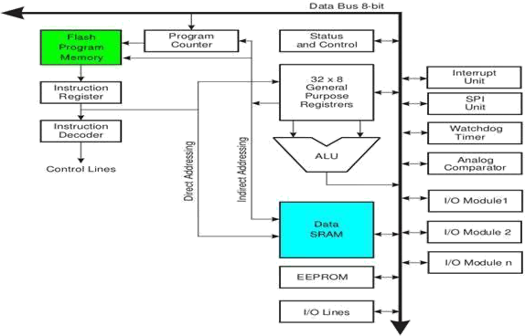

**V. CONCLUSION**

The GSM-based electronic notice board prototype has been successfully designed. Its mobility is demonstrated by the ease with which it may be incorporated with any general-purpose display board. The system accepts the message to be displayed in the form of Short Message Service (SMS), stores it, checks for its validation and then displays it on the display unit if it from an authorized user. Only one message can be supported at a time by this system. Extended RAM and a more expensive microcontroller can be used to overcome this restriction. The proposed system can be efficiently used for transfer of message instantly in the campus.

These days, all advertisements will be digital. These days, computerized moving displays are used in large stores and retail malls. Digital moving displays at train stations and bus stops provide anything from platform numbers to ticket information. But in these displays if they want to change the message they have to go to the place of the display and connect the display to PC or laptop. Suppose the same message is to be displayed in main centers of cities to display critical messages then we have to go there with a laptop and change the message by connecting it to the display board. This project is primarily useful for the army or police to show important information in a few seconds. In light of this, we are using GSM technology to develop a new display system that we can access remotely. This project is a modem-connected remote notice board. so if the user wants to display some messages, he will send the messages in SMS format. The modem in the display system will receive the message and update the display according to the message. For every message received, the system will check for the source number and if the source number incorrect the controller will display the message. The outcome of this project is an embedded system providing wireless transmission from one point to the other via a GSM network. In addition to removing the drawbacks of earlier mass communication techniques, this system provides a dependable and quick data transfer medium. In addition to the many uses already discussed, it has a lot of room for improvement in the area of embedded systems, where telecommunication is an essential component. As such, it has the potential to completely transform current communication systems.

#### REFERENCES

1. Darshankumar C. Dalwadi, Ninad Trivedi , Amit Kasundra “Wireless notice board our real-time solution” National Conference on Recent Trends in Engineering & Technology.
2. Nivetha S. R, Pujitha. R, Preethi Selvaraj & Yashvanthini S.M “SMS based Wireless Notice board with monitoring system” International Journal of Advanced Electrical and Electronics Engineering, (IJAEEE) ISSN (Print) : 2278-8948, Volume-2, Issue-3, 2013.
3. Price of Basys™2 Spartan-3E FPGA Board retrieved on 13th August 2014 from <http://www.digilentinc.com/Products>